* **What is Spring Framework?**

Spring is a **Java framework** used for building enterprise-level applications. It provides **dependency injection (DI)** and **aspect-oriented programming (AOP)** to simplify development.

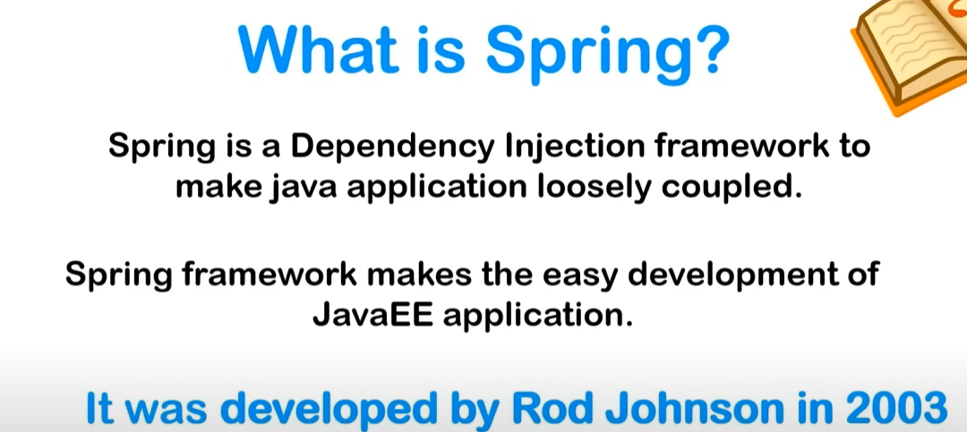

**🔹 Why Use Spring?**

* **Removes Boilerplate Code** – Reduces unnecessary code.
* **Flexible Configuration** – Supports XML, Java-based, and annotation-based configurations.
* **Built-in Support for JDBC, Hibernate, JPA, Security, and Web Development.**

**Core Concepts to Learn in Spring**

* **1. Inversion of Control (IoC) & Dependency Injection (DI)**
* **What is IoC?**  
  IoC means that instead of creating objects manually (new ClassName()), Spring manages the object creation and lifecycle.
* **What is DI?**  
  DI is a technique where Spring automatically injects dependencies into a class rather than us creating them manually.

**1. What is Spring Boot?**

Spring Boot is a **framework built on top of Spring** that simplifies development by:  
✅ **Auto Configuration** – Reduces manual setup.  
✅ **Starter Dependencies** – Adds required libraries automatically.  
✅ **Embedded Server** – No need to set up Tomcat separately.

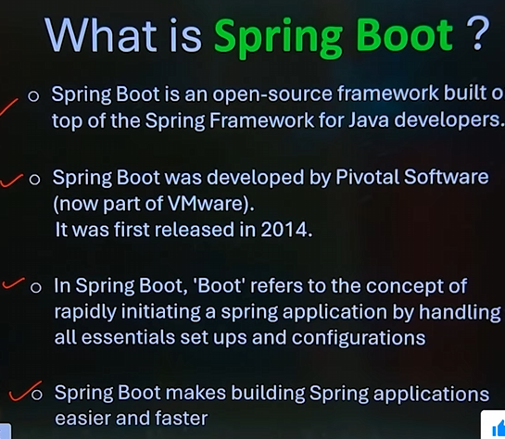

**🔹 Real-Life Example: Imagine Building a Website Without Hassle**

* Traditional Spring: You need to **manually configure everything** (web server, dependencies, etc.).
* Spring Boot: It comes with **pre-configured settings** so you can **focus on coding**!
* **Spring Boot** **Starter Dependencies**
* **What are Starter Dependencies?**
* Spring Boot provides **starter dependencies** that bundle commonly used libraries, so you don’t have to add them manually.
* **Common Starter Dependencies**

| **Dependency** | **Purpose** |
| --- | --- |
| spring-boot-starter-web | For building web applications & REST APIs |
| spring-boot-starter-data-jpa | For database access using JPA & Hibernate |
| spring-boot-starter-security | For adding authentication & authorization |
| spring-boot-starter-thymeleaf | For building web applications with Thymeleaf |